SCM using GitHub

Table of Contents

Walkthrough 3

1 : Working in GitHub 5

This Activity demonstrates the usage of GitHub.

Working in GitHub
1 | Creating a GitHub Account:  - Login to https://github.com/signup in new browser.  - Create new account by giving username, email address and password and login.  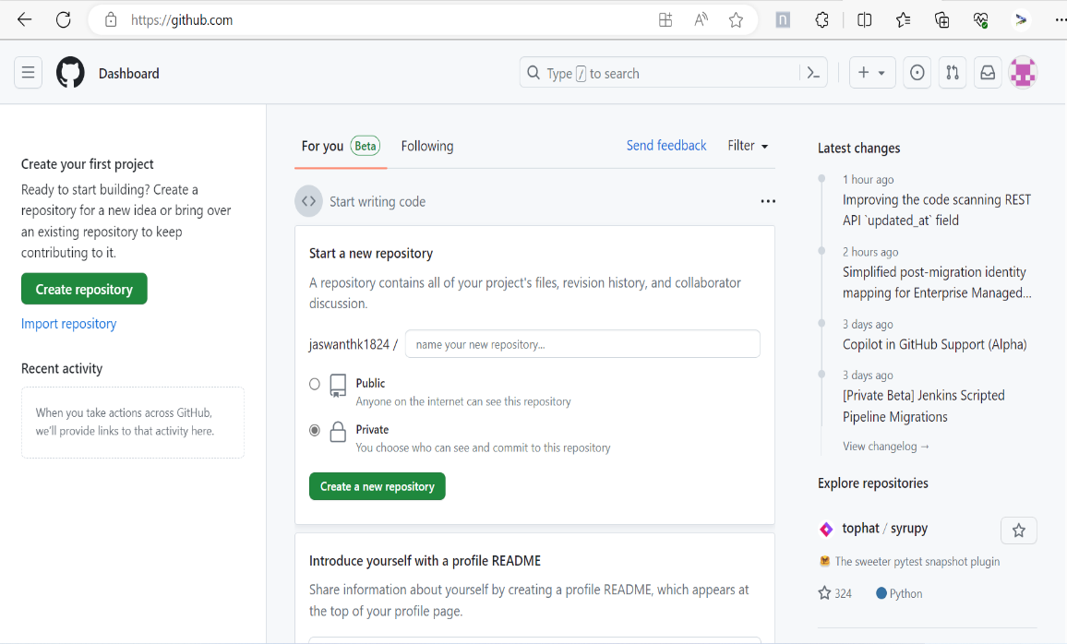
2 | Creating Github Repository:  1. Click New repository to create a repository.  2. Provide name of new Repository Example: demoproject.  3. Select for Public button.  4. Check “Initialize this repository with a README”  5. Click Create repository.  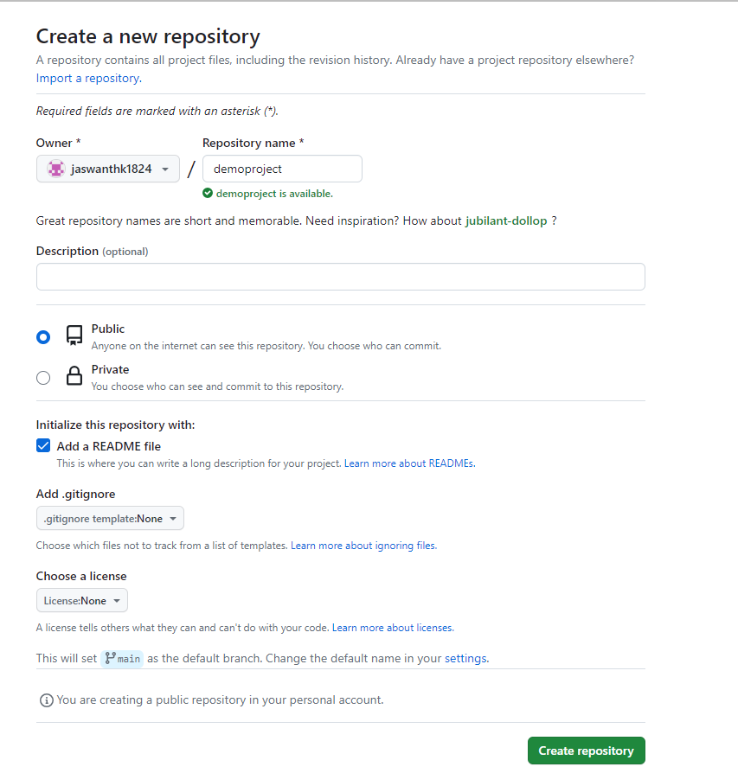  Please review your repository created as below:  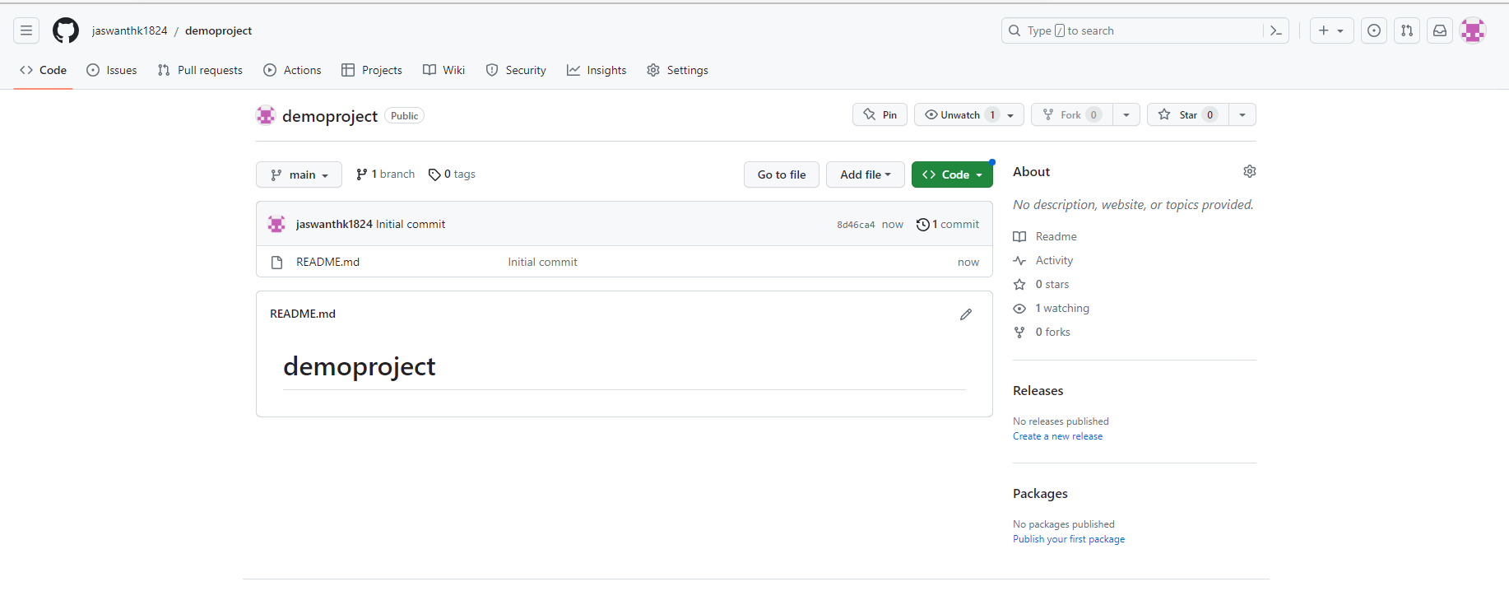
3 | Adding a new file  - Click Create new file.  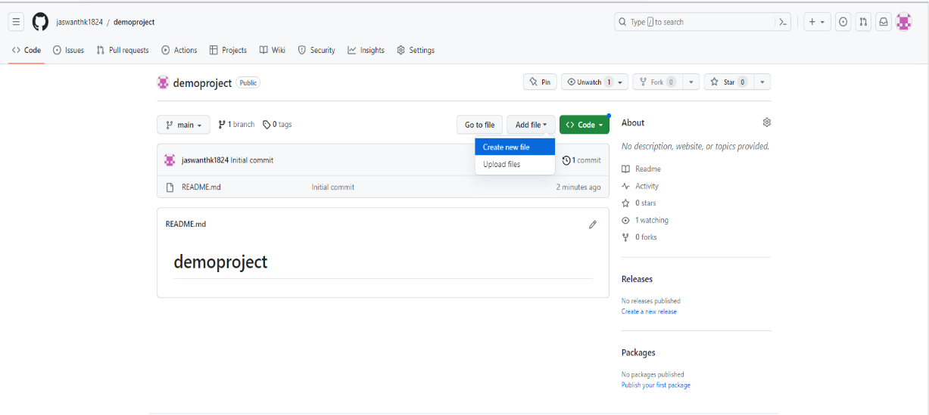  - Name the file. For this exercise “samplecode.sh”  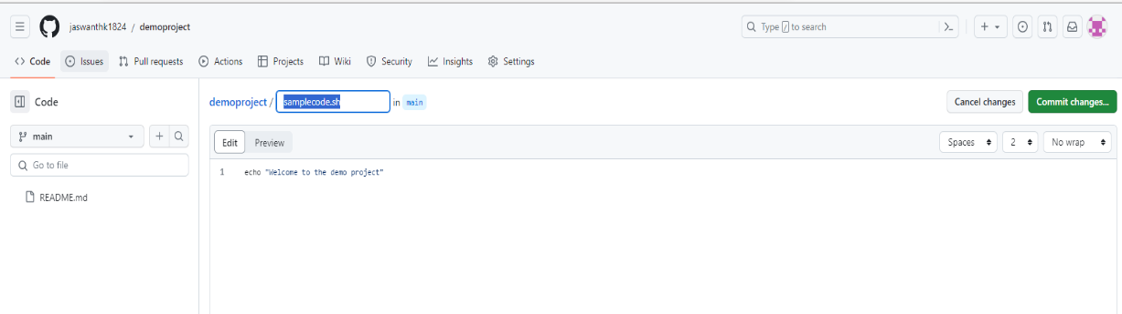  - Add lines of code.  For example:  echo “welcome to the demo project”  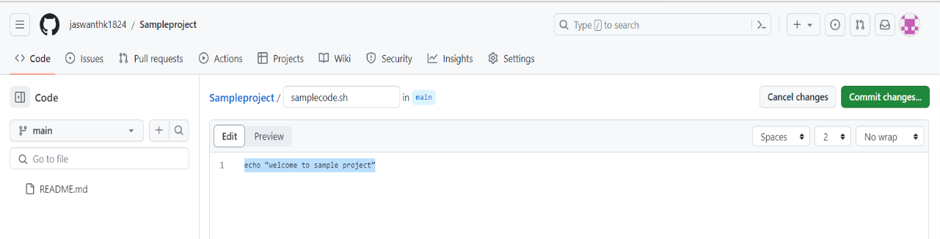  - Click on Commit Changes…  - Add Commit message as shown below.  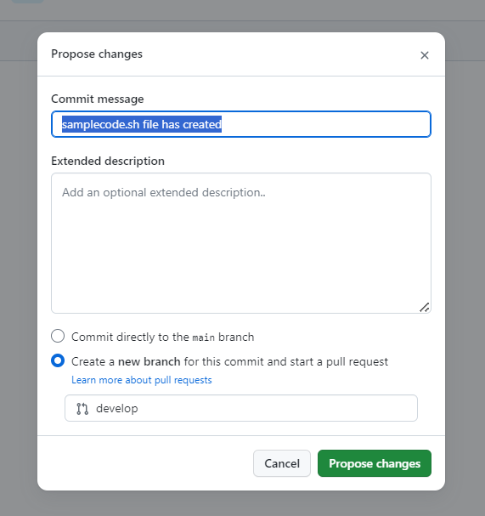  - Ensure that create a new branch for this commit and start a pull request and provide branch name as develop as shown above.  - Click on Propose Changes  - Now add comments and click on create pull request  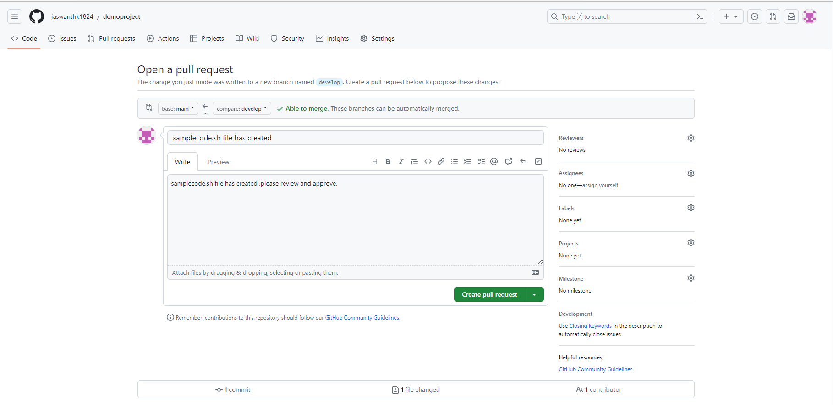  9.Now click on merge pull request and confirm merge.  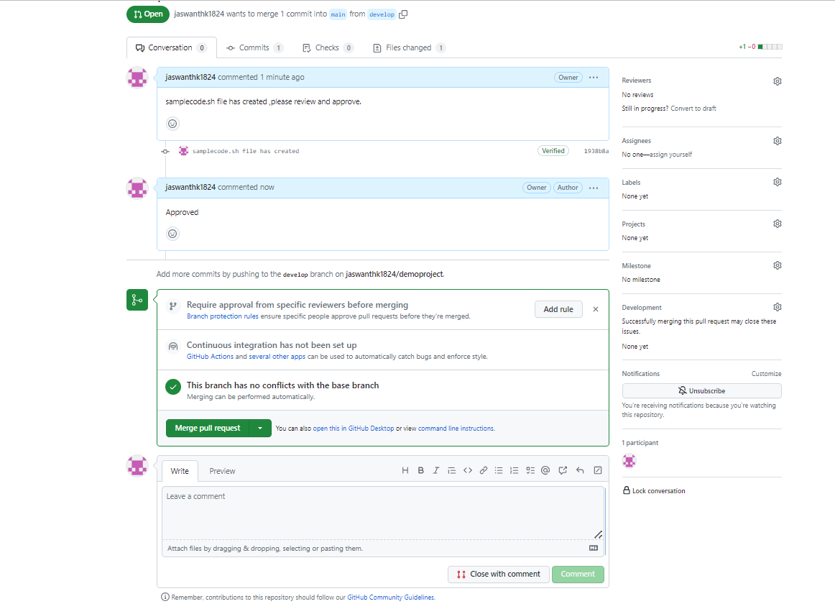  10.Pull request is successfully merged and closed and verify your newly created file in main branch.  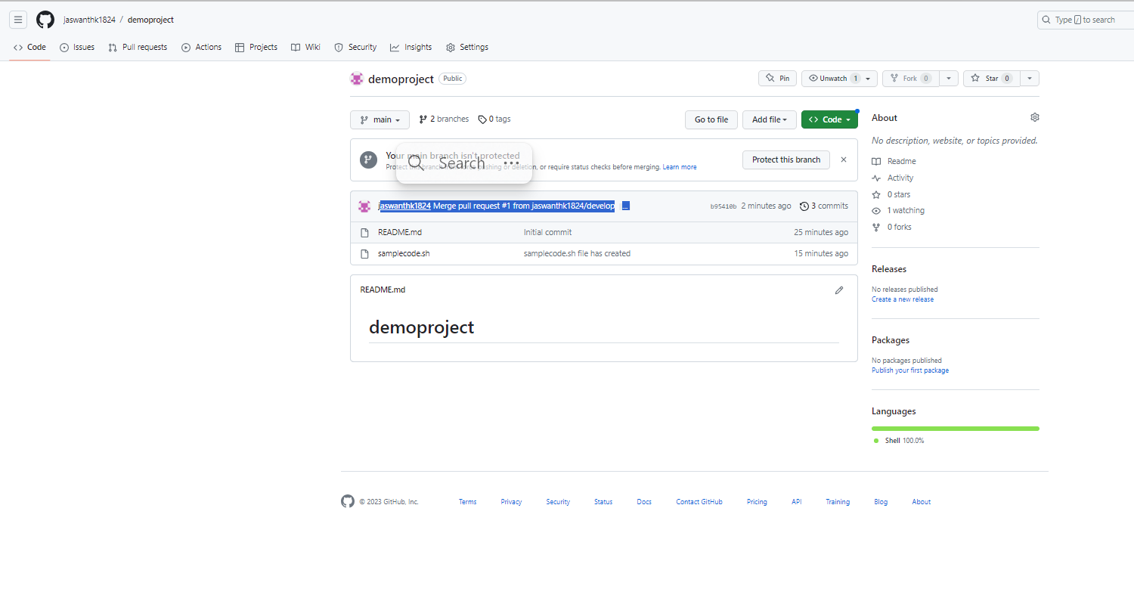
4 | Editing an existing file  1.Go to develop branch in branches tab  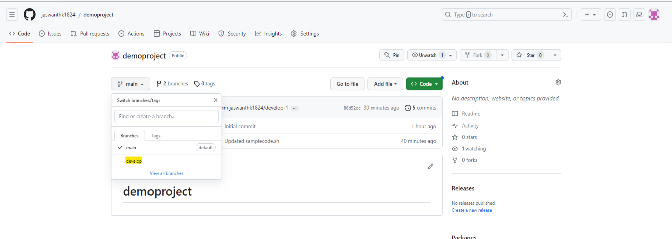  2.click on the samplecode.sh file  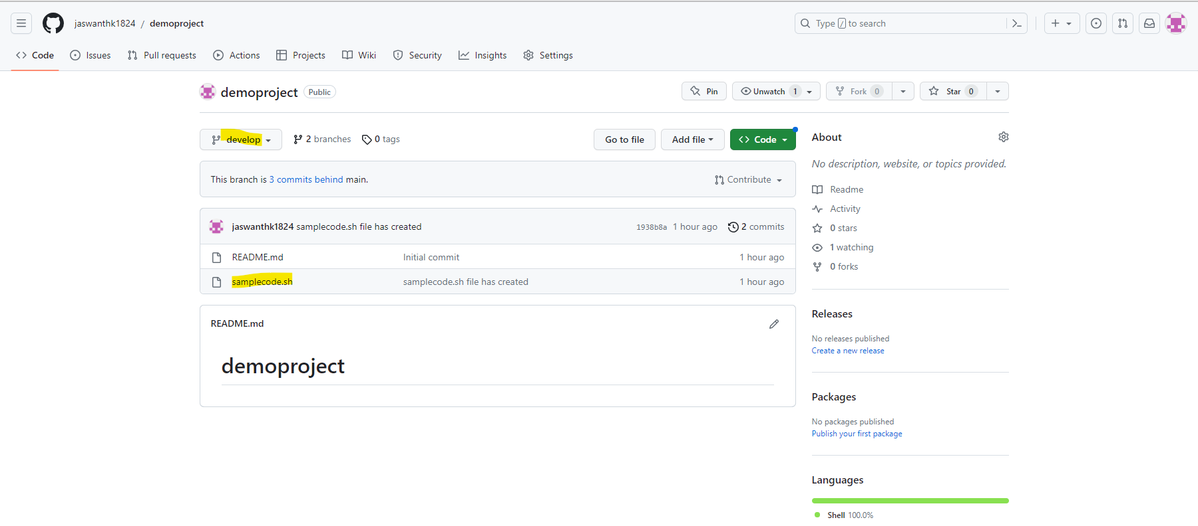  3.Edit the file content in the Edit file tab  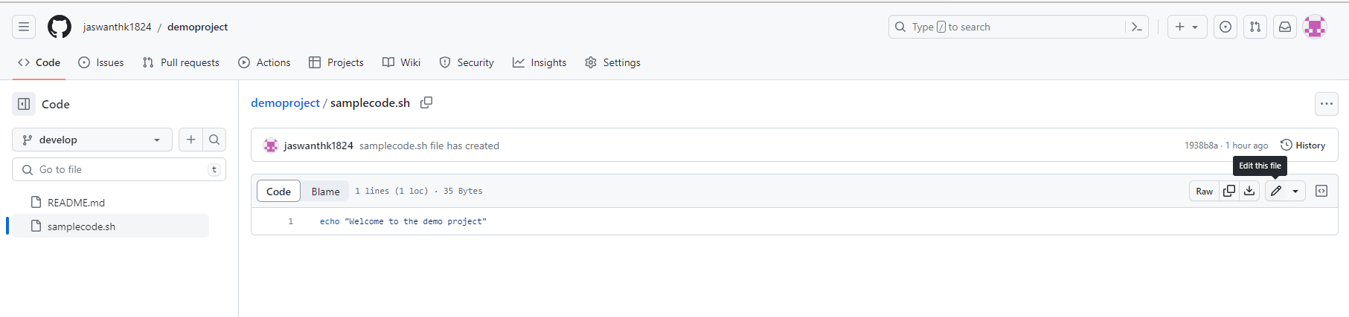  Now modify the content of the file, here added a new line  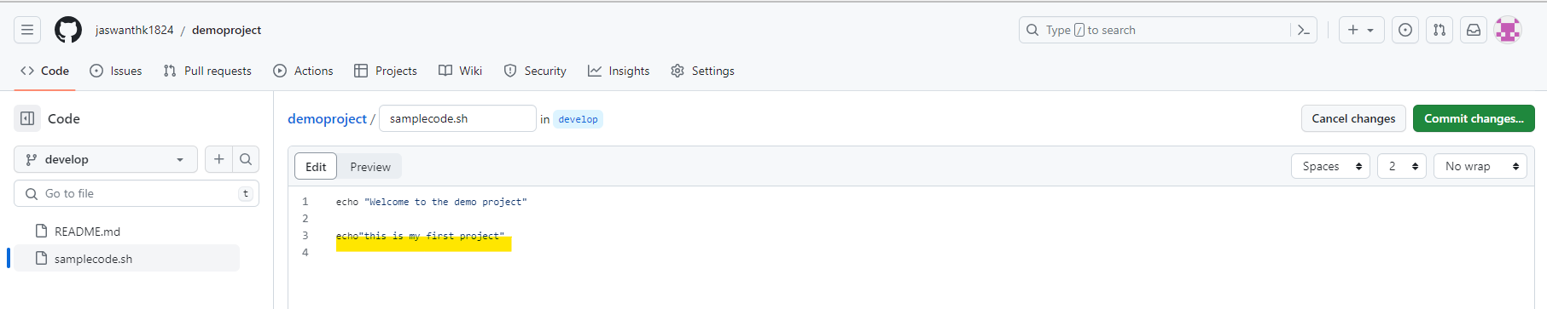  4.Click on Preview to view the changes. The new content will be displayed in Green, click on commit changes.  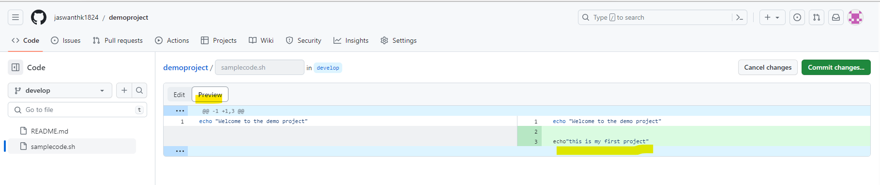  5.Give a meaningful comment when committing which explains the changes made to the file.  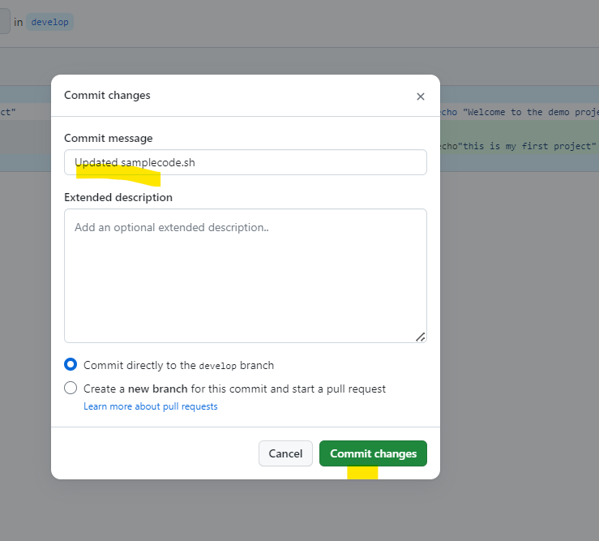  6.Click on commit Changes  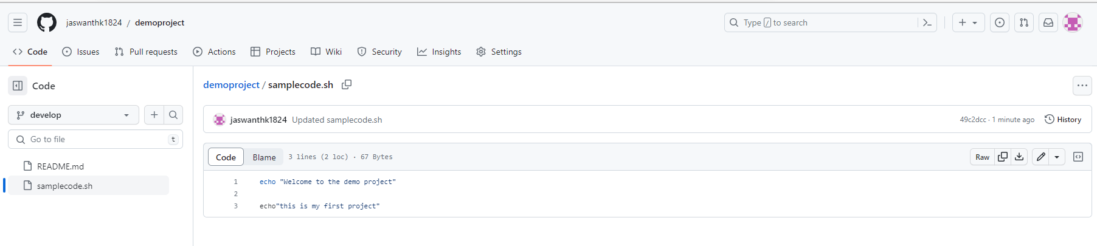  7.Navigate to main branch and create pull request to merge changes from develop branch into main branch  8.click on compare & pull request and confirm merge  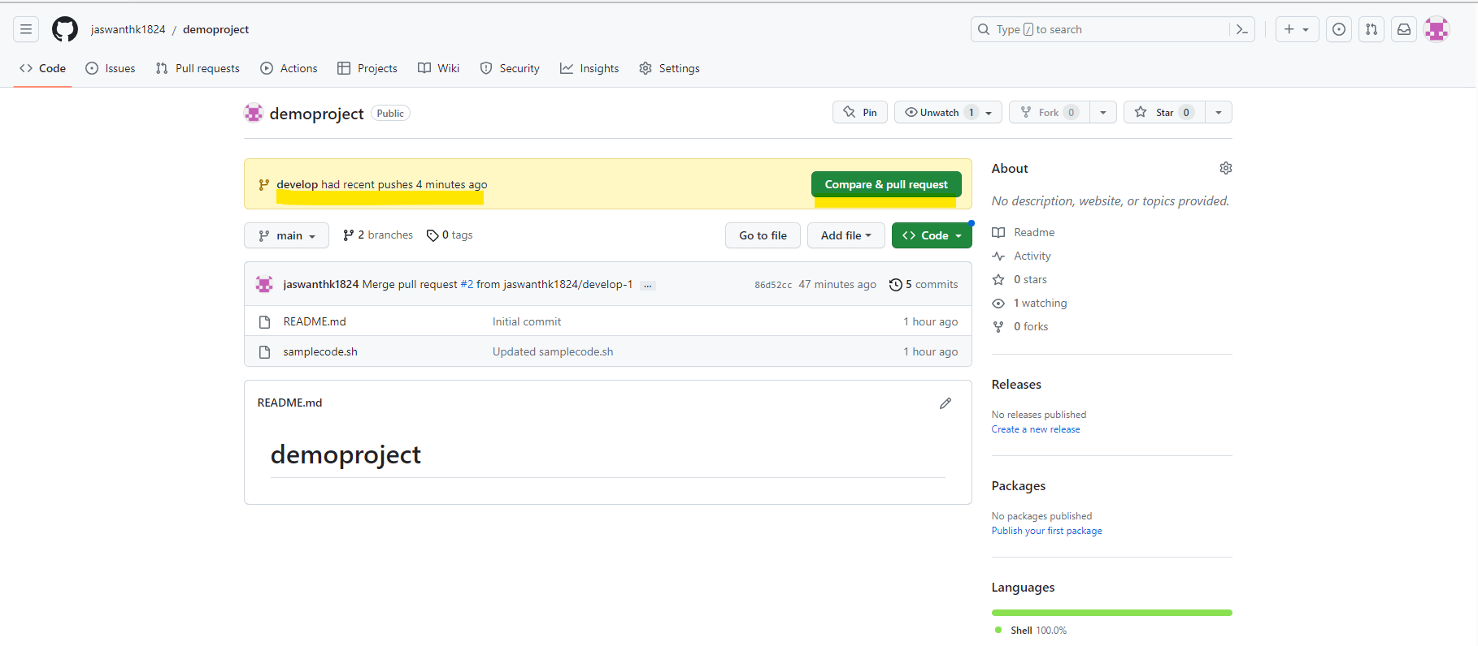  8.click on create pull request  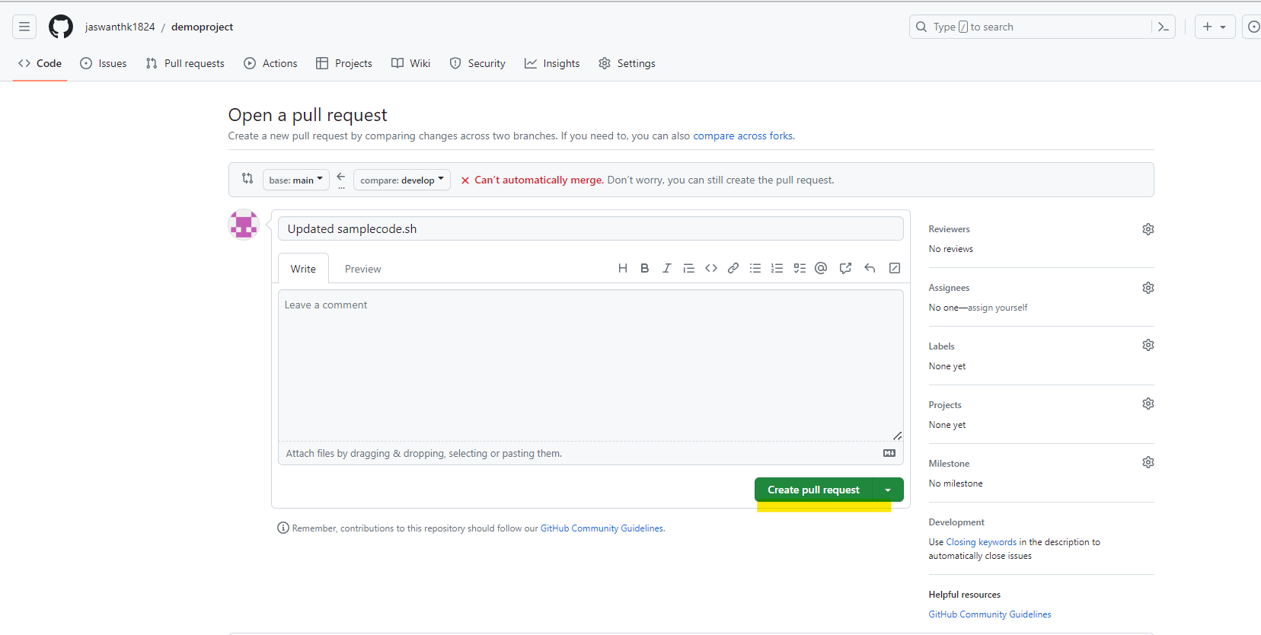  9.click on merge pull request and confirm merge  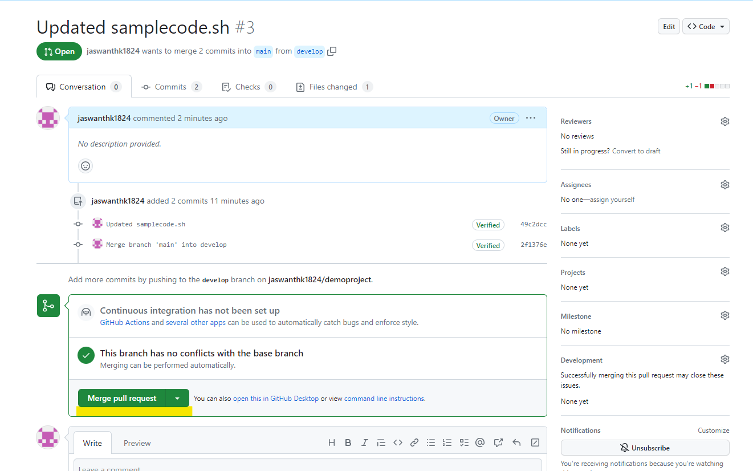  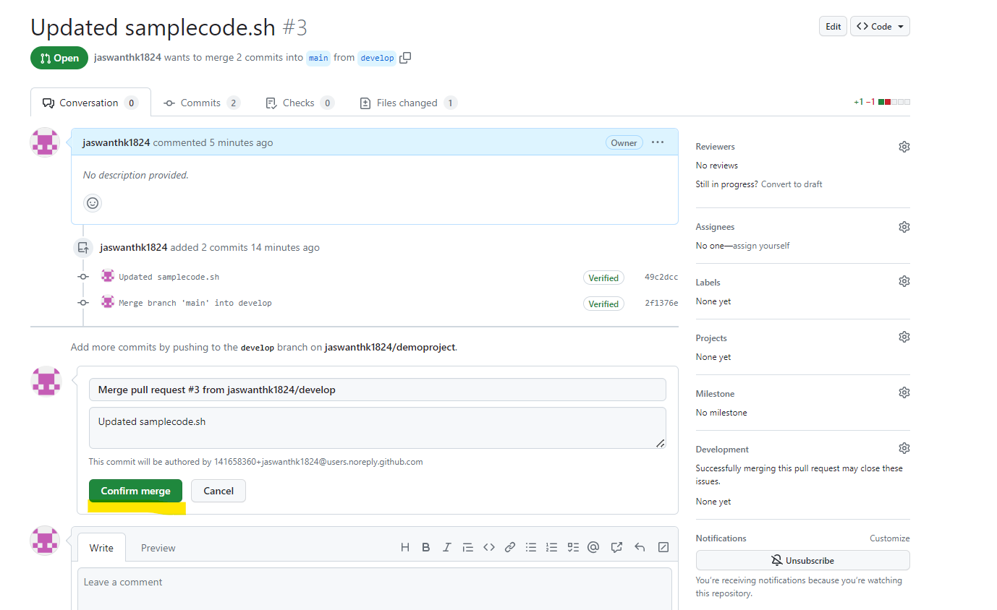  - Now pull request is successfully merged and closed,  - Navigate to main branch and click on file to see the updated content.  